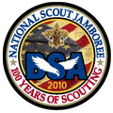 Troop 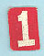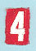 Jamboree 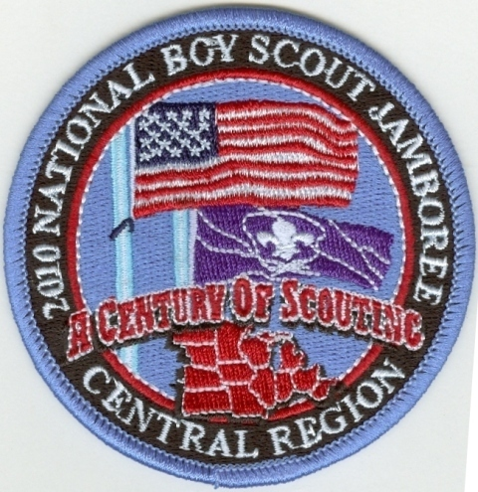
Patrol news
(July)
Troop 1444 has its own web site: http://www.ncis.net/troop1444 Check it out.

 We have a new departure time; its 12:00 noon on Sunday July 25th. We will be leaving from the Miller Hill Mall parking lot (Behind Yonkers). We ask that all participants be there 2 hour before departure time. If you are late for the bus, we will not wait. We are on a tight schedule and must leave on time. When you come we ask that you please have a bag lunch or that you have eaten a good sized meal before- hand. If you are bringing water bottles / camelbacks, it only makes sense to have them filled before you leave, so please fill them. Also, make sure you have broken up your travel goods (backpack) from your camping goods (Duffel bag). The duffel bag will be stored under the bus and you will not have access to it until we arrive on site. Your backpack will be stored in an overhead compartment. Keep all items you might want during the trip in the backpack.

 The trip to Virginia is a long one and you’re going to need to sleep. I suggest you bring a pillow on board the bus for doing so. This will also free up some space in your bag. Just a suggestion.
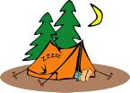 All of Troop 1444 tents have been dried out for their next use; the tents & components are now labeled and will be reassigned to the users. This way if a piece is lost, we know who, what, why and where it belongs. This will also work well for any tents not returned properly after the jamboree.

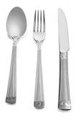 Eating utensils were not left in the patrol boxes per request. Because of this, please make sure you pack yourself a quality fork, spoon and dinner knife in your duffle bag. NO DISPOSABLE TYPE, they will not last the week. Have your name or at least your initials on each piece so that they do not get mixed up, or if lost & found we know who they belong to.

 (This is not the merit badge emblem) A new merit badge to be offered only at the jamboree; the Mining merit badge. There will be no book, you simply need to show up and do the requirements. So if you are looking for something really different, there you go. This information was published in the June CN Rail Road Magazine. If doing MB’s is your thing, this might be one to consider.
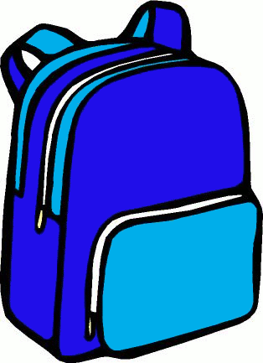 Extra stuff: You may want to pack a few unnecessary things that could be nice to have, if you have the room.

One item that I see being most handy is a pocket rain poncho (The $1.00 type). If the skies are clear, you probably won’t pack your rain gear for the day, but with the poncho you have insurance just in case.
A second item is a pocket fan. Very small hand held fan that runs on 2 AA batteries. They are very nice after a long walk in the sun. Wal-Mart sells them for about $3.00. Not the spray type, they cause sunburn.
Neck coolers are great. Again, Wal-Mart for about $3.00. You soak them in water and they stay cool for 2-3 hours. I brought 2 last time.
Back up utensils. If you are using plastic, which I like the best, having extra can be a life saver.
A sewing kit. You never know if those pants will rip.
Aqua socks: Slip on water shoes for going back and forth to the showers (About 3+ blocks away, and also for when at the water park. Walking on the concrete walk-ways all day can be hard on the tootsies.

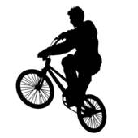 Exercise: Don’t forget to exercise before the trip. If you haven’t started a walking or cycling workout yet, please do. Everyone will be walking more than usual and a little work before the trip could go a long way. You have 2 weeks to get ready; adults too. Toughen up those feet and strengthen those leg muscles. You will be happy you did. MAX.

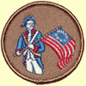 Patriot Patrol (4)
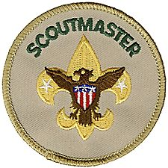 Chris Campbell: Scoutmaster Swim test passed, Lifeguard, $20.00
Youth records, Jamboree
records.
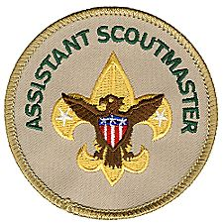 Scott Tollefson: 1st Assistant Scoutmaster Swim test passed, Lifeguard, $20.00
Treasure, News letter, tent tags.
Todd Reynolds: 2nd Assistant Scoutmaster Swim test passed, $20.00
Build Troop 1444 web site, QM adviser, Youth photo id’s.
Josh Ensign: 3rd Assistant Scoutmaster $20.00
Youth adviser, over see gateway.

 Eh! Patrol (4)

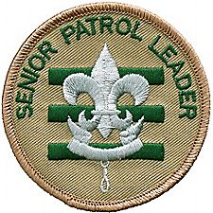 Chris Giuffre: Senior patrol Leader Swim test passed, $20.00
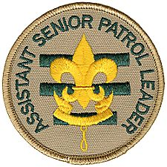 Max Tollefson: Assistant Senior Patrol Leader Swim test passed, Lifeguard, $20.00

Sean Ferrell: Assistant Senior Patrol Leader Swim test passed, Lifeguard, $20.00

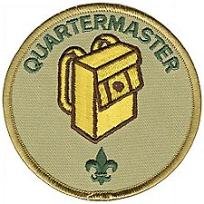 Stephen Reynolds: Quartermaster Swim test passed, $20.00

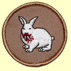 Killer Rabbits Patrol (8)

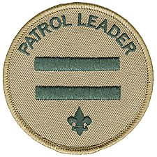 Sean Miller: Patrol Leader Swim test passed

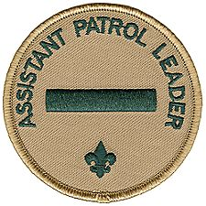 Mike Beeksma: Assistant Patrol Leader Swim test passed, $20.00

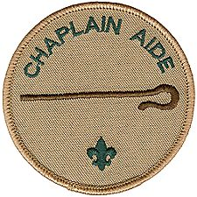 Ian Nichols: Chaplain Aide Swim test passed, $20.00

Dakota Lindsey Swim test passed, $20.00
Dustyn Godfrey Swim test passed, $20.00
Alex Bourdage Swim test passed, $20.00
Kyle Alton Swim test passed, $20.00
Sam Jorgenson Swim test passed,

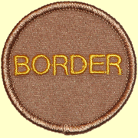 Border Patrol (8)
Joe John: Patrol Leader Swim test passed, $20.00

Bill Trethewey: Assistant Patrol Leader Swim test passed, $20.00

Elliot Schmaltz : Chaplain Aide Swim test passed, $20.00

Nate Weaver Swim test passed
Jeshuah Peterson Swim test passed, $20.00
Jacob Alton Swim test passed, $20.00
Jared Elder Swim test passed, $20.00
Shane Pufall Swim test passed, $20.00

 Gnome Patrol (8)

Sam Anderson: Patrol Leader Swim test passed, $20.00
Robert Bodin: Assistant Patrol Leader Swim test passed, $20.00

Isaac Gilliland : Chaplain Aide Swim test passed, $20.00

Zach Weaver Swim test passed
Jeff Clancey Swim test passed $20.00
Stephen Aleshire Swim test passed, $20.00
Niccolo Pufall Swim test passed, $20.00
Zach Olsen Swim test passed, $20.00

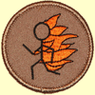 Flaming Stickmen Patrol (8)
Micah Peterson: Patrol Leader Swim test passed, $20.00

Tim Cline: Assistant Patrol Leader Swim test passed, $20.00

Andrew Greaves: Chaplain Aide Swim test passed, $20.00

Sam Seelos Swim test passed, $20.00
Eric Sauer Swim test passed, $20.00
Austin Moore Swim test passed, $20.00
Nathan Budney Swim test passed, $20.00
Sam Kemp Swim test passed, $20.00

Check that packing list! Pack at least a week before you go and then after a couple of days go by, recheck everything. I’ll bet most everyone will find at least one more thing they want to take with them. They always do.

Yours in Scouting,

Scott Tollefson

